VR Tour

259 Lakeshore Blvd. E.

Toronto Biennial of Art

**Editorial Briefing**

This virtual-reality tour will offer viewers a look into a repurposed car dealership at 259 Lakeshore Blvd. E., one of two main sites for the inaugural Toronto Biennial of Art, a free citywide art event taking place until Dec. 1.

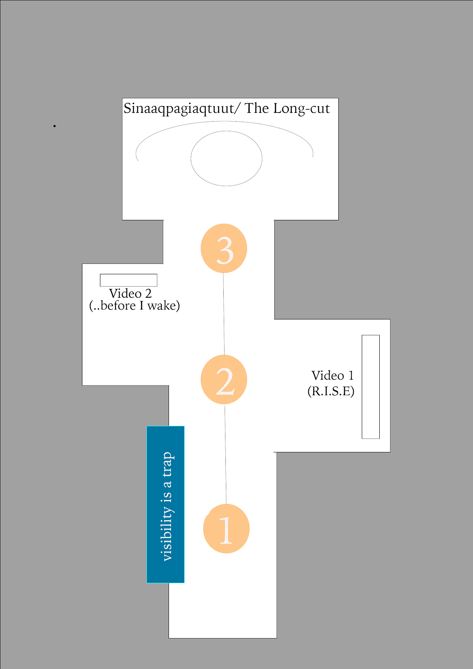

The tour will take viewers through three separate locations in the warehouse-like building. The three locations are situated in a large open-concept corridor.

Viewers walk in a straight line from the west end of the corridor to the east end of the corridor to get from location 1 to location 2 to location 3.

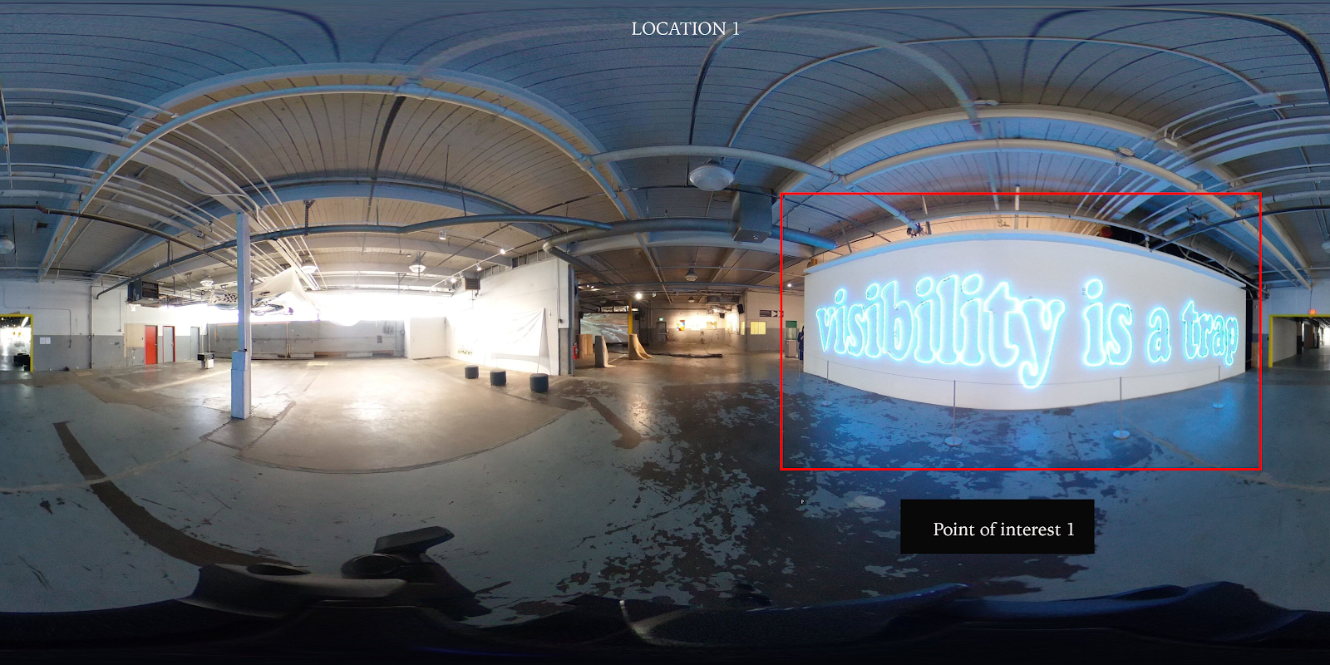

Viewers will begin their tour at location 1 on the west end of the corridor, where they will see the first point of interest, a neon-light piece by Laurent Grasso entitled *Visibility is a Trap* on their left.

Viewers will be able to hover over the piece, prompting a pop-up text box to appear that offers more information about the artist and artwork.

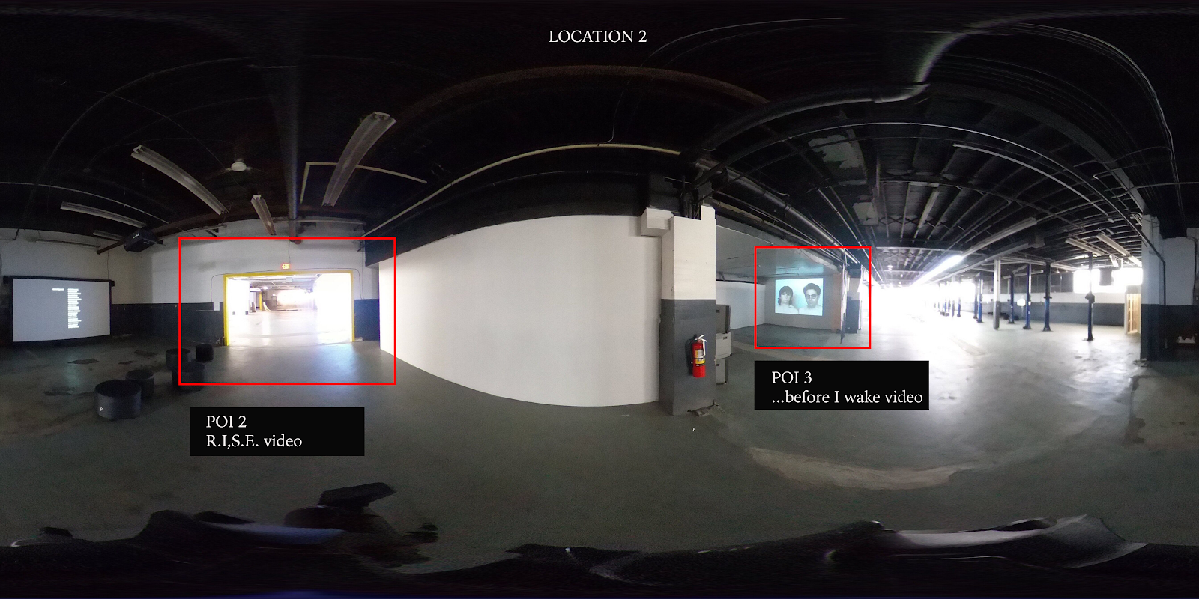

Viewers will then walk about 10 feet east to arrive at location 2, where they will see two points of interest: Barbara Wagner and Benjamin de Burca’s *R.I.S.E.*, an experimental documentary about poets, rappers and musicians in Toronto’s underground music scene on their left, and Lisa Steele and Kim Tomczak’s *… before I wake*, a video triptych that explores aging, relationships and other themes on their right.

Viewers will be able to hover over each piece, prompting pop-up text boxes to appear that offer more information about each of the artists and video projects.

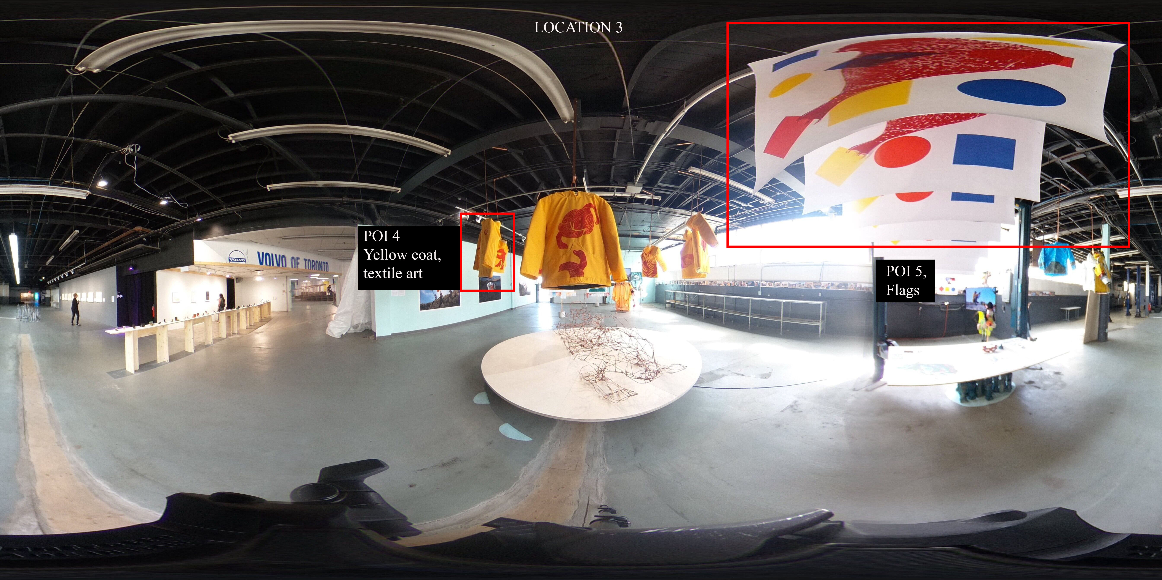

Viewers will then walk another 10 feet east to arrive at location 3, where they will see the final point of interest: *Sinaaqpagiaqtuut/The Long-Cut*, a multidisciplinary project comprised of photographs, sculptures, textile art and other works by Embassy of Imagination and PA System.

Viewers will be able to hover over the flags displayed in the top right-hand corner, prompting a pop-up text box to appear that offers more information about the artists and exhibit.

Viewers will also be able to hover over one of five yellow coats hanging in the centre, which will prompt a pop-up photo box to appear that displays a close-up image of the coat.

This close-up image will be accompanied by text in the pop-up box that offers more information about this specific piece of textile art in the exhibition.